**BTech ECE - Quantum University - Batch 01 - Task 04 - Prototyping Model.**

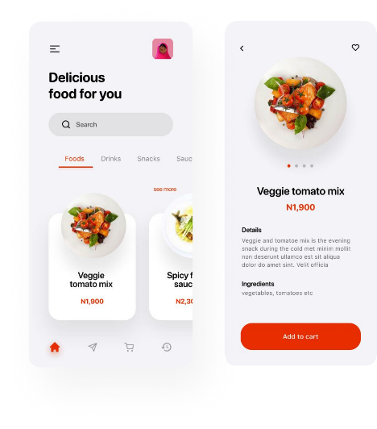

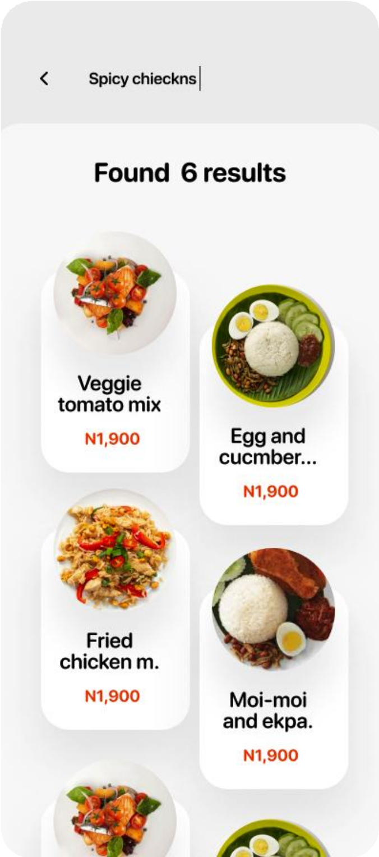 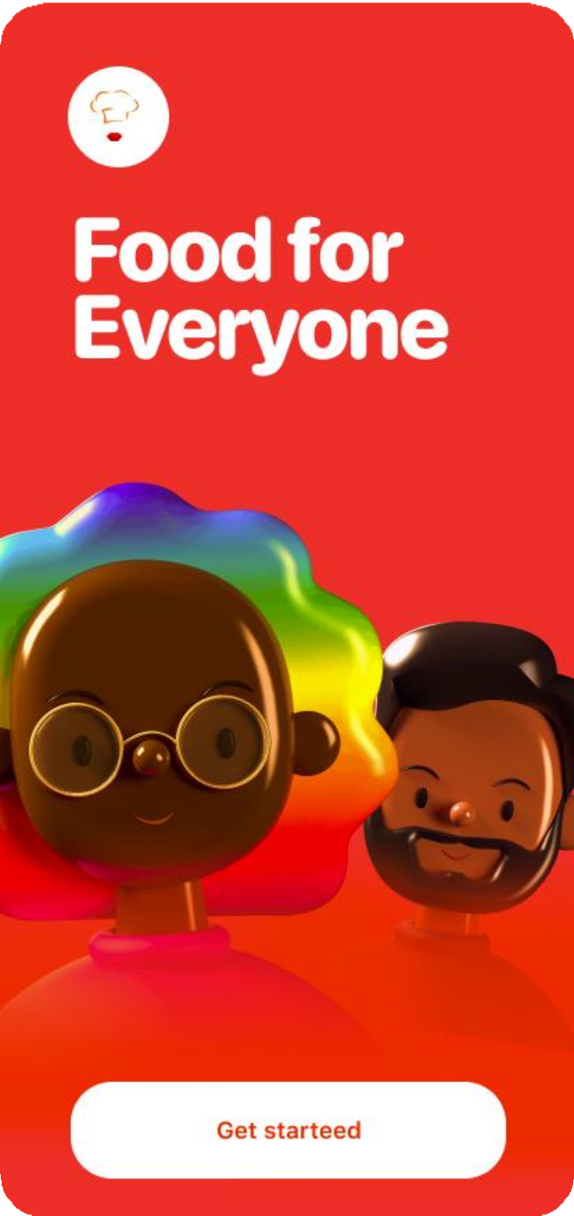

**1. Product Selection: Food Delivery App.**

**Objective:** Create a food delivery application that allows users to browse restaurants, view menus, place orders, and track deliveries.

**Target Users:** Individuals who order food online, restaurants, and delivery personnel.

**Key Features:**

* User authentication (Login/Signup)
* Search and filter restaurants/food items.
* Order placement and tracking.
* Payment integration (UPI, Cards, Wallet)
* Ratings and reviews for restaurants.
* Admin panel for restaurant management.

**2. Solution Design in Figma.**

**Tools Needed:** Figma (for UI/UX design), Figma plugins (for icons, wireframing, prototyping)

**Workflow:**

**1. Wireframing:** Create low-fidelity wireframes of core screens (Home, Menu, Cart, Checkout, Order Tracking).

**2. UI Design:** Add high-fidelity UI elements (Typography, Colors, Icons).

**3. Prototype:** Link screens for interactive navigation.

**3. Screens Based on the Image.**

* **Home Screen:** "Food for Everyone" landing page with a welcome message.
* **Search & Menu Page:** List of dishes with prices.
* **Product Details:** Dish description, ingredients, price, and an "Add to Cart" button.
* **Cart & Checkout:** Order summary, payment options, and delivery details.